HW#3 MSEG 302 The University of Delaware Spring 2018

 a) What are the chemical formulas and molecular weights of the repeat units for the following polymers?

Chemical structures from Wikipedia

(1) polystyrene

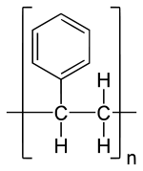

(C8H8)n = 104.15 g/mol

(2) polytetrafluoroethylene

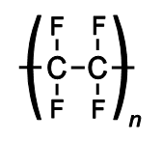

(C2F4) = 100.02 g/mol

(3) poly(methyl methacrylate)

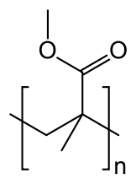

(C5O2H8)n = 100.12 g/mol

(4) nylon 6,10

Here is the correct short-hand structure of nylon 6,10:

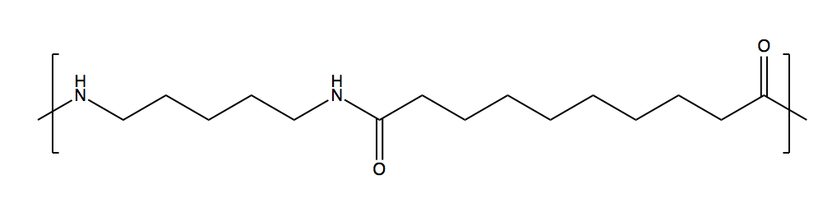

(C16O2N2H30)n = 282.43 g/mol

I did find a link on the web to the nylon 6,10 salt… this is the precursor used to synthesize nylon 6,10 involving the small molecule precursors hexamethylene diamine and sebacic acid (decanedioic acid), it therefore has the extra water molecule that is lost during the polymerization reaction and so has a slightly larger molecular weight of 318.458 g/mol (C16H34N2O4).

https://pubchem.ncbi.nlm.nih.gov/compound/165736#section=Top

(5) poly(ethylene terephthalate)

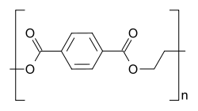

(C10H8O4)n = 192.17 g/mol

(6) polypropylene

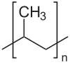

(C3H6)n = 42.08 g/mol

(7) poly(vinyl chloride)

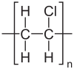

(C2H3Cl)n = 62.50 g/mol

 b) You are given 4 different samples of monodisperse polystyrene. The first sample (1) has a molecular weight of 1,000 g/mol, the second (2) is 10,000 g/mol, the third (3) is 100,000 g/mol, and the fourth (4) 1,000,000 g/mol. Consider a 4 g mixture comprised of 1 g of sample (1), 1 g of sample (2), 1 g of sample (3), and 1 g of sample (4).  What would be the number-average molecular weight of such a mixture?  What would be the weight-average molecular weight of the final mixture?  What would be the number average degree of polymerization of the final mixture?  What would be the weight average degree of polymerization of the final mixture?  What would be the polydispersity index (PDI) of the final mixture?

mass of repeat unit: m0 = 104.15 g/mol (from problem 1)

m1=1000 g/mol

m2=10000 g/mol

m3=100000 g/mol

m4=1000000 g/mol

Total mass of species 1: tm1 = 1 g

Total mass of species 2: tm2 = 1 g

Total mass of species 3: tm3 = 1 g

Total mass of species 4: tm4 = 1 g

Number of moles of species 1: n1 = tm1/m1 = 1/1000

Number of moles of species 2: n2 = tm2/m2 = 1/10000

Number of moles of species 3: n3 = tm3/m3 = 1/100000

Number of moles of species 4: n4 = tm4/m4= 1/1000000

m1 = 1000 g/mol

m2 = 10000 g/mol

m3 = 100000 g/mol

m4 = 1000000 g/mol

tm1 = 1 g

tm2 = 1 g

tm3 = 1 g

tm4 = 1 g

n1 = tm1/m1

n2 = tm2/m2

n3 = tm3/m3

n4 = tm4/m4

mn = N[(m1 n1 + m2 n2 + m3 n3 + m4 n4)/(n1 + n2 + n3 + n4)] = 3600 g/mol

mw = N[(m1^2 n1 + m2^2 n2 + m3^2 n3 + m4^2 n4)/(m1 n1 + m2 n2 +

m3 n3 + m4 n4)] = 277,750 g/mol

PDI = N[mw/mn] = 77.1

xn = mn/m0 = 34.6

xw = mw/m0 = 2667

This PDI is much broader than is typical for a given polymer; this is because of the wide range of molecular weights specified in this mixture.

Note the important distinction between the number of moles of a given species i (the ni in the equations for Mw and Mn) and the number of repeat units in a given chain.

 c) Sketch the repeat structure for each of the following alternating copolymers: (1) poly(ethylene-propylene), (2) poly(butadiene-styrene), (3) poly(isobutylene-isoprene).

Using shorthand notation for convenience:

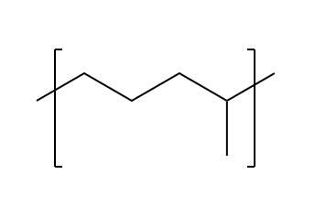

(1) poly(ethylene-propylene)

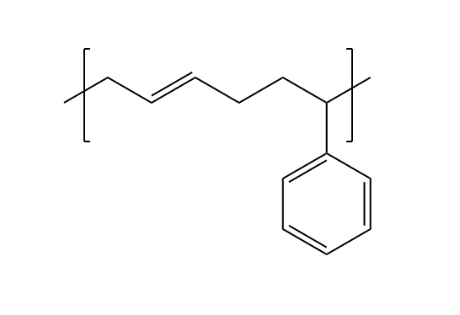

2) poly(butadiene-styrene)

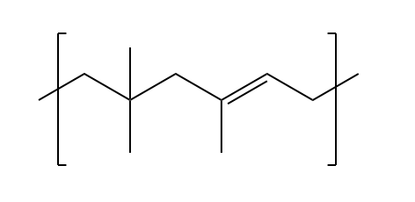

poly(isobutylene – isoprene)

 d) The density and associated percent crystallinity (by mass) for two different samples of poly(ethylene terephthalate) are:(1) density 1.41 g/cm3, crystallinity = 74%, and (2) density 1.34 g/cm3, crystallinity 31%. Compute the densities of totally crystalline and totally amorphous poly(ethylene terephthalate) (PET). If there was one repeat unit of PET per unit cell in the crystal, what would be the unit cell volume?  If a third sample of PET was found to have a density of 1.38 g/cm3, what would be its degree of crystallinity (by mass)?

From notes, text:mass fraction crystallinity xc = (c/s)(s-a)/(c-a)

For density1 = 1.41 g/cm, xc = 0.74

For density2 = 1.34 g/cm, xc = 0.31

d1 = 1.41 g/cm3

x1 = 0.74

d2 = 1.34 g/cm3

x2 = 0.31

x1 = (dc/d1) (d1 - da)/(dc - da)

x2 = (dc/d2) (d2 - da)/(dc - da)

Two equation, two unknowns. Use algebra, or solve in 1 line with *Mathematica*:

Solve[{x1 == (dc/d1) (d1 - da)/(dc - da), x2 == (dc/d2) (d2 - da)/(dc - da)}, {da, dc}]

gives da=1.2937 g/cm^3, dc=1.45599 g/cm3.

Mass of PET repeat unit: 192.17 g/mol (problem 1)

Mass of fully crystalline PET: 1.45599 g / cm3

density = mass/volume

so volume = mass / density

For one repeat unit: (192.17 g/mol) (Nav) / 1.45599 g/cm3 = 2.19 10-22 cm3 or 0.219 nm3

if d3 = 1.38 g/cm3,

(dc/d3) (d3 - da)/(dc - da) = xc = 0.56 = 56%